NAME: Sharvayu Zade
PRN: 23070521135
SEC: B(B2)

Practical 3 Part 3
Ways to Take Input in JavaScript
JavaScript can collect input from users using various methods:
1. HTML Form Elements (via DOM)
This is the most common method for user input in web applications. Example:
<input type="text" id="name" />
<button onclick="getName()">Submit</button> <script>
function getName() {
let name = document.getElementById("name").value; alert("Hello, " + name);
}
</script> 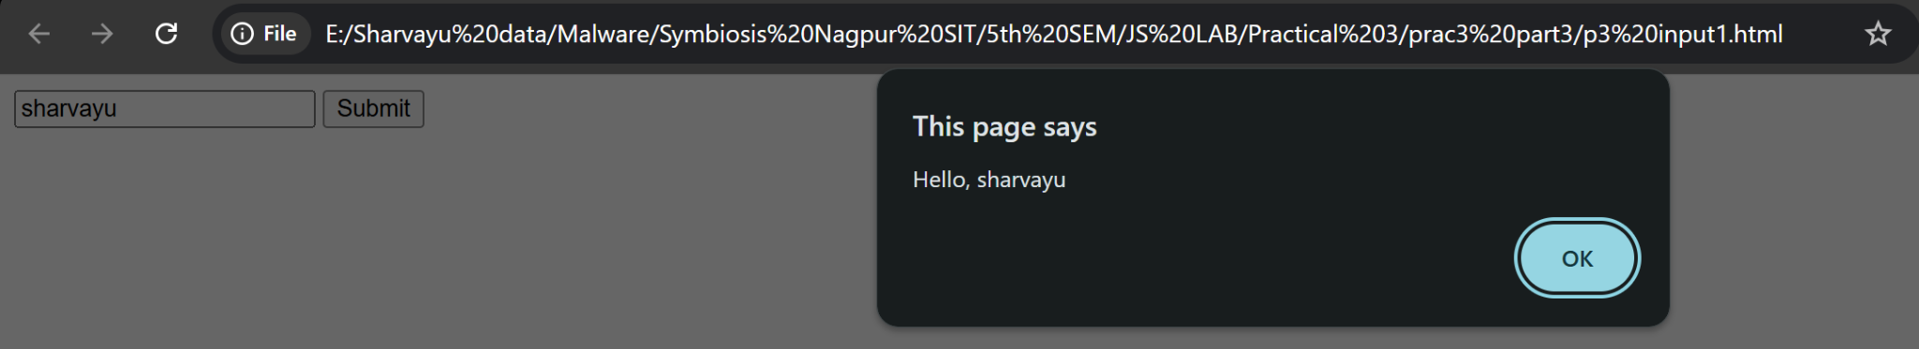
Input Types:
Type | Description
text | Single line input
number | Numeric input only
password | Hidden characters
email | Valid email format

radio | Single choice from group
checkbox | Multiple selections
date | Calendar input
range | Slider input
file | Upload files
textarea | Multi-line input
select | Drop-down menu

2. prompt() (Browser Dialog Box)
Useful for quick input during testing or simple applications.
let name = prompt("Enter your name:"); alert("Hello, " + name); 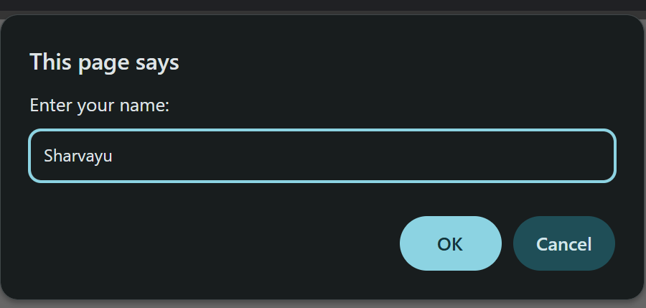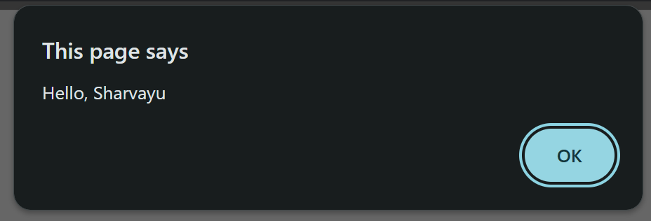
3. Event Listeners (Real-time Input Capture)
You can capture input as the user types using events like keyup, change, etc.
Syntax
document.addEventListener(event, function, Capture)
<input type="text" id="liveInput" placeholder="Type something"> <p id="display"></p>
<script>
document.getElementById("liveInput").addEventListener("keyup", function() {
document.getElementById("display").innerText = this.value; });
</script> 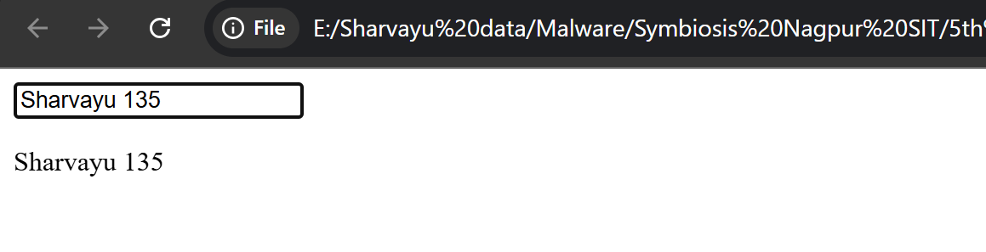
4. Form Submission with submit Event
Ideal for processing form data in a structured way.
<form id="myForm">
<input type="number" name="marks" />
<button type="submit">Submit</button>
</form>
<script>
document.getElementById("myForm").addEventListener( "submit", function(e) {
e.preventDefault(); // Prevent reload
let marks = this.marks.value;
alert("Marks entered: " + marks);
});
</script> 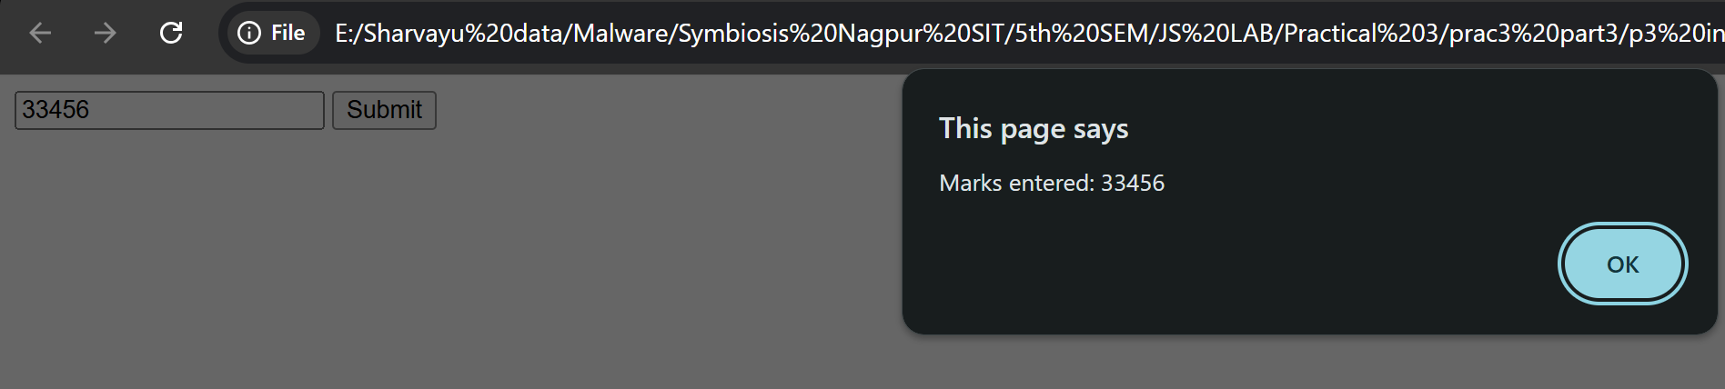
5. File Input (Read File Data)
Used when the user uploads a file.
<input type="file" id="fileInput">
<script>

document.getElementById("fileInput").addEventListener( "change", function() {
const file = this.files[0];
alert("Selected file: " + file.name);
});
</script> 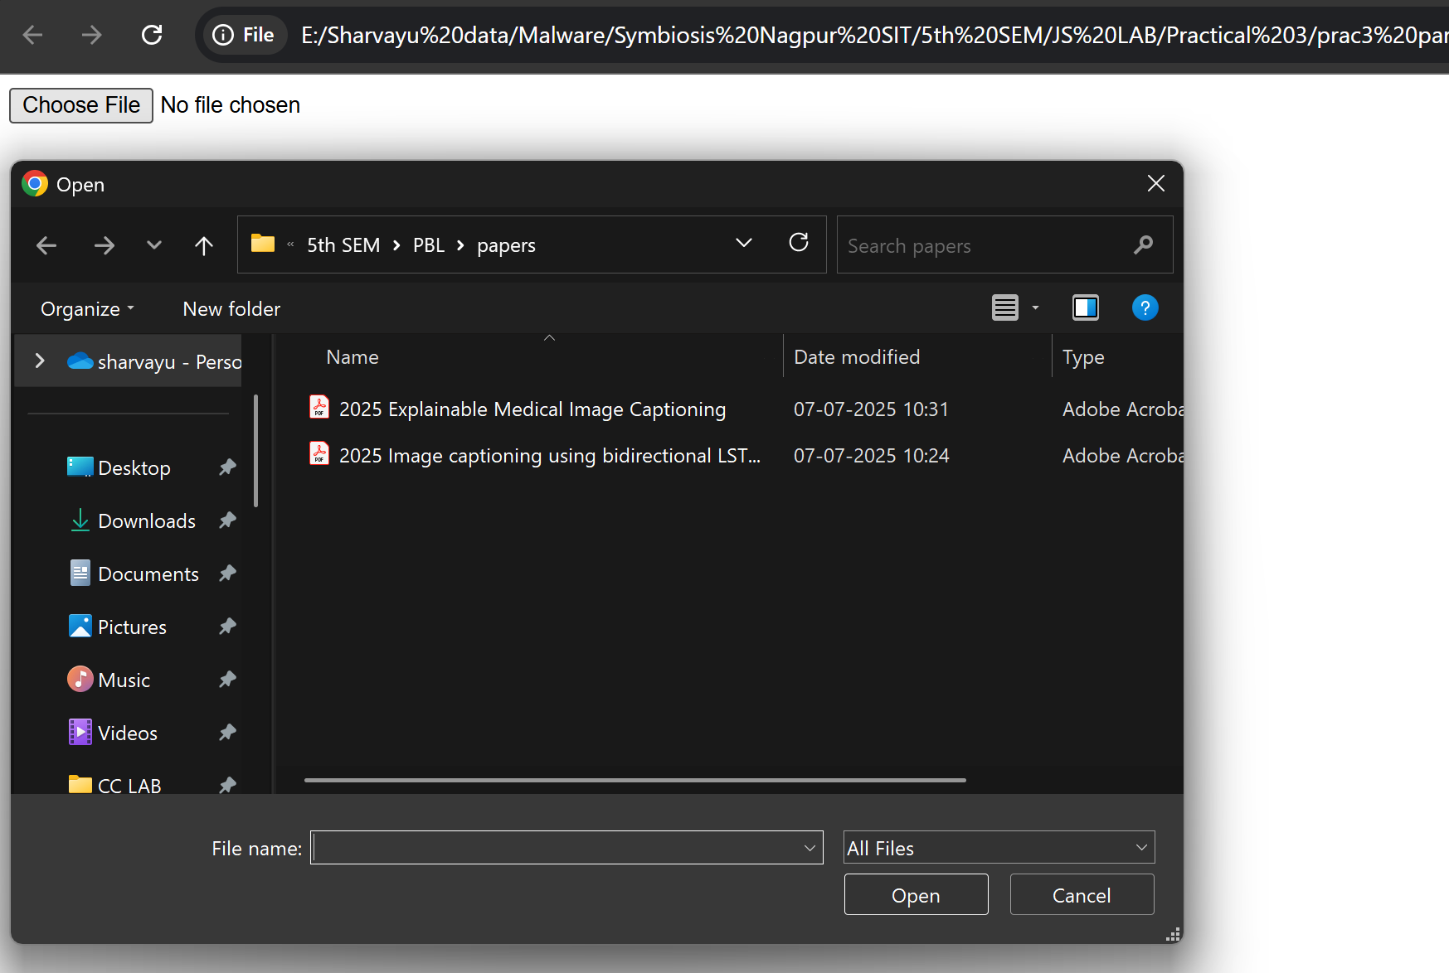
6. URLSearchParams (Query Parameters)
If values are passed through the URL.
const params = new
URLSearchParams(window.location.search); const name = params.get('name'); // ?name=John
Input controls Details
Method | Use Case Example | Real  Time? | Common  In
prompt() | Simple text input (testing) | No | Quick apps
input elements | Text, number, password, etc. | Yes | Forms
textarea | Multi-line input | Yes | Feedback
select / option | Dropdown selections | Yes | Menus
radio / checkbox | Multiple/Single options | Yes | Surveys
file input | Upload documents/images | Yes | Uploads
URLSearchParams | Get data from URL | No | Routing
Event Listeners  (keyup, change) | Capture typing in real-time | Yes | Live  preview

Task:
Create a grading system that classifies grades based on marks entered by the user.